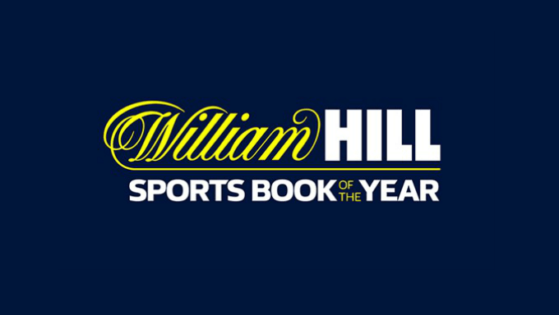
2024 William Hill Sports Book of the Year Award Entry Form

This form is acceptable for 2024 entries. Dates may be subject to alteration.
Please submit one entry form per title. Closing date for entries is Friday 30th August 2024, all books must be received by Tuesday 3rd September 2024.

PRIZES:
- The winning author will receive £30,000 and a trophy.
- Shortlisted authors will receive a leather-bound copy of their book and £3,000 cash.

- Please return this completed form, a hi-res image of the author, a hi-res image of the front cover of the book, a biography, a book press release and a pdf version of the title by email to whsboty@williamhill.co.uk to enter.

- Please also send 10 copies of the nominated title(s) by post to the following address: William Hill Sports Book of the Year Award, c/o William Hill, St John’s Centre, Leeds, LS2 8JF.

- Title:
Date of publication:
Author:
Author Twitter:
Publisher:
Publisher Contact:
Publisher Contact email:
Publisher Twitter Handle:
Cover Designer:
Publicist’s name:
Publicist’s email:
It is a strict condition of entry that publishers agree to ensure that authors whose books are submitted make themselves available for publicity. If longlisted, authors will be required to partake in a William Hill Sports Book podcast and if shortlisted, authors will be expected to attend the award ceremony in late November 2024. If there is any problem with the author’s availability, please contact whsboty@williamhill.co.uk.
We agree to abide by the rules of the competition for the above prize, applicable to books with scheduled publication dates between 2nd September 2023 – 30th September 2024.

Signature:
Date:
William Hill Sports Book of the Year rules:
- Any full-length book, the subject of which is predominantly sporting, is eligible. In the event of the winning title having more than one author, the judges reserve the right to either split the prize or award additional prizes as agreed by the panel of judges.
- All books nominated must be published in the UK for the first time during the period 2nd September 2023 and 30th September 2024 (Publication in another country prior to a UK publishing date will not disqualify a book).
- For the award, a sporting book is one which the judges agree meets the criteria for consideration for the award. Their decision in this and all other matters pertaining to the award will be binding.
- Publishers may enter any number of books, provided they are all scheduled for publication (or have already been published) as per rule 2. Entry form must be received by the ‘Organising Committee’ before close of business on Friday, 30th August 2024. Ten copies of each title must be received before close of business on Tuesday 3rd September 2024.
- Provided entries are scheduled for publication before 30th September 2024, the judges will accept proof copies of the book up to 6th September 2024. In exceptional circumstances, provided they are submitted in time for them to be accorded the necessary consideration the judges reserve the right to accept additional entries. The judges’ decision on this matter will be final and no correspondence will be entered into.
- Following the closing date for a nomination, the ‘Organisation Committee’ will circulate a full list of nominations to the judges. The judges will have the right to call in other titles at any time thereafter with due consideration to Rule 5.
- The ‘Organisation Committee’ shall nominate several titles to be considered in depth by the judges and will ask the respective publishers to supply a further ten copies of those books. The ‘Organising Committee’ also reserves the right to call for a further 10 copies of any and each book so-called for by any one of the judges under Rule 6.
- From the judges’ deliberations, a long list of titles from those considered will be announced in September 2024.
- From the judges’ deliberations, a shortlist of titles from those considered will be announced in October 2024.
- The award winners will be announced in late November 2024. The publishers of the shortlisted titles will be called upon by the ‘Organising Committee’ to supply 20 copies of the shortlisted titles for use at the reception which will be held to mark the award ceremony.
- The publisher of the winning title agrees to use the words “William Hill (as a logo) Sports Book of the Year 2024” as a front cover flash for any subsequent reprints of the winning title, hardback or paperback.
- The prize will be £30,000 for the author and a trophy.
- All shortlisted authors will receive a leather-bound copy of their book and £3,000 cash.
- Each shortlisted author must be available to attend the Prize Ceremony held in late November 2024.
- Longlisted and shortlisted authors should be prepared to undertake media interviews, appear on a William Hill podcast and wherever possible, make reference to the Prize on their own websites/blogs.
- Any publisher submitting an entry form for the Award is automatically bound by these rules.

